PIZZA Sales SQL queries

1. KPI’s
2. Total Revenue:

Select sum(total_price) as total_revenue from pizza_detail

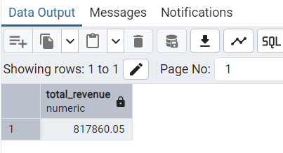

1. Average order value

Select sum(total_price)/ count(distinct order_id) as Avg_order_value from pizza_detail

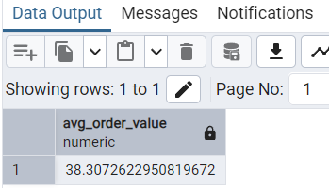

1. Total pizza sold

select sum(quantity) as total_pizza_sold from pizza_detail

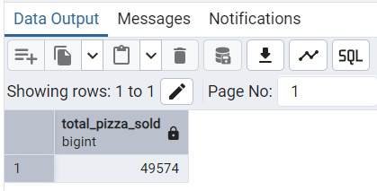

1. Total orders:

Select count(distinct order_id) as total_order from pizza_detail

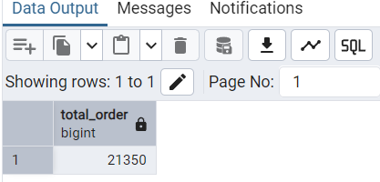

1. Average pizza per order

select sum(quantity)/count(distinct order_id) as average_pizza_per_order from pizza_detail

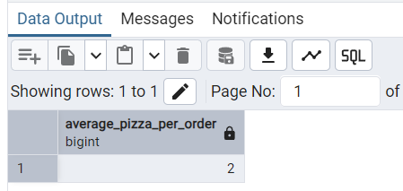

1. Trends for total order

1.Daily Trend for Total orders

SELECT TO_CHAR(order_date,'Day') as order_day, count(Distinct order_id) as Total_orders

from pizza_detail

GROUP BY order_day;

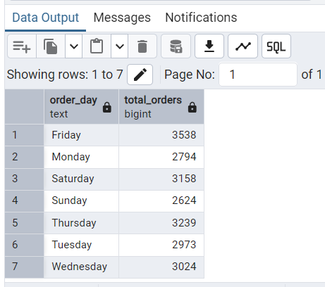

2. Hourly Trend for Total orders:

SELECT EXTRACT(HOUR FROM order_time) as order_hour,count(distinct order_id) as Total_orders

from pizza_detail

group by order_hour

order by order_hour;

